

Yedi Risdianto | 200511033 | TI20D

Aplikasi perhitungan menggunakan konsep Object Oriented Programming (OOP)

1. **Persegi Panjang**

Source Code :

from tkinter import Frame, Label, Entry, Button, YES, BOTH, END, Tk, W

class FrmPersegiPanjang:

def __init__(self, parent, title):

self.parent = parent

self.parent.geometry("500x500")

self.parent.title(title)

self.parent.protocol("WM_DELETE_WINDOW", self.Keluar)

self.aturKomponen()

def aturKomponen(self):

mainFrame = Frame(self.parent, bd=10)

mainFrame.pack(fill=BOTH, expand=YES)

# pasang Label

Label(mainFrame, text='Panjang:').grid(

row=0, column=0, sticky=W, padx=5, pady=5)

Label(mainFrame, text="Lebar:").grid(

row=1, column=0, sticky=W, padx=5, pady=5)

Label(mainFrame, text="Luas:").grid(

row=3, column=0, sticky=W, padx=5, pady=5)

Label(mainFrame, text="Keliling:").grid(

row=4, column=0, sticky=W, padx=5, pady=5)

# pasang textbox

self.txtPanjang = Entry(mainFrame)

self.txtPanjang.grid(row=0, column=1, padx=5, pady=5)

self.txtLebar = Entry(mainFrame)

self.txtLebar.grid(row=1, column=1, padx=5, pady=5)

self.txtLuas = Entry(mainFrame)

self.txtLuas.grid(row=3, column=1, padx=5, pady=5)

self.txtKeliling = Entry(mainFrame)

self.txtKeliling.grid(row=4, column=1, padx=5, pady=5)

# Pasang Button

self.btnHitung = Button(mainFrame, text='Hitung',

command=self.Hitung)

self.btnHitung.grid(row=2, column=1, padx=5, pady=5)

# fungsi untuk menghitung luas dan keliling persegi panjang

def Hitung(self, event=None):

panjang = int(self.txtPanjang.get())

lebar = int(self.txtLebar.get())

perspanj = persegipanjang(panjang, lebar)

luas = perspanj.luas()

kel = perspanj.keliling()

self.txtLuas.delete(0, END)

self.txtLuas.insert(END, str(luas))

self.txtKeliling.delete(0, END)

self.txtKeliling.insert(END, str(kel))

def Keluar(self, event=None):

# memberikan perintah menutup aplikasi

self.parent.destroy()

class persegipanjang():

# perhitungan dengan metode Pemrograman OOP

def __init__(self, panjang, lebar):

self.panjang = panjang

self.lebar = lebar

def luas(self):

return self.panjang * self.lebar

def keliling(self):

return (2 * self.panjang) + (2 * self.lebar)

if __name__ == '__main__':

root = Tk()

aplikasi = FrmPersegiPanjang(root, "OOP! Program Luas dan Keliling Persegi Panjang")

root.mainloop()

Hasil Program Persegi Panjang ;

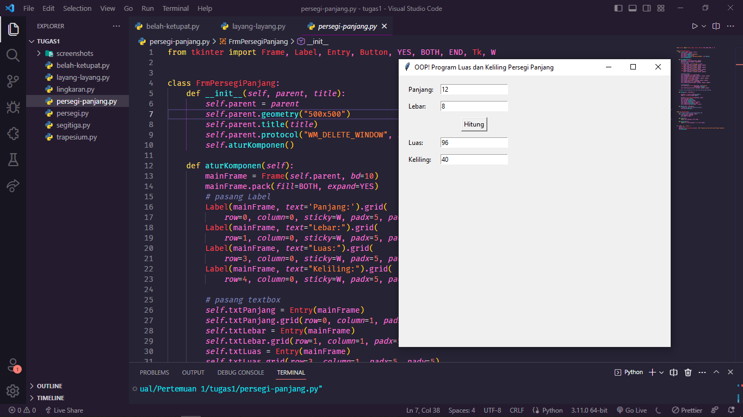

1. **Segitiga**

Source Code :

from tkinter import Frame, Label, Entry, Button, YES, BOTH, END, Tk, W

class FrmSegitiga:

def __init__(self, parent, title):

self.parent = parent

self.parent.geometry("500x500")

self.parent.title(title)

self.parent.protocol("WM_DELETE_WINDOW", self.Keluar)

self.aturKomponen()

def aturKomponen(self):

mainFrame = Frame(self.parent, bd=10)

mainFrame.pack(fill=BOTH, expand=YES)

# pasang Label

Label(mainFrame, text='Alas:').grid(

row=0, column=0, sticky=W, padx=5, pady=5)

Label(mainFrame, text="Tinggi:").grid(

row=1, column=0, sticky=W, padx=5, pady=5)

Label(mainFrame, text="Sisi a:").grid(

row=2, column=0, sticky=W, padx=5, pady=5)

Label(mainFrame, text="Sisi b:").grid(

row=3, column=0, sticky=W, padx=5, pady=5)

Label(mainFrame, text="Sisi c:").grid(

row=4, column=0, sticky=W, padx=5, pady=5)

Label(mainFrame, text="Luas:").grid(

row=6, column=0, sticky=W, padx=5, pady=5)

Label(mainFrame, text="Keliling:").grid(

row=7, column=0, sticky=W, padx=5, pady=5)

# pasang textbox

self.txtAlas = Entry(mainFrame)

self.txtAlas.grid(row=0, column=1, padx=5, pady=5)

self.txtTinggi = Entry(mainFrame)

self.txtTinggi.grid(row=1, column=1, padx=5, pady=5)

self.txtSisia = Entry(mainFrame)

self.txtSisia.grid(row=2, column=1, padx=5, pady=5)

self.txtSisib = Entry(mainFrame)

self.txtSisib.grid(row=3, column=1, padx=5, pady=5)

self.txtSisic = Entry(mainFrame)

self.txtSisic.grid(row=4, column=1, padx=5, pady=5)

self.txtLuas = Entry(mainFrame)

self.txtLuas.grid(row=6, column=1, padx=5, pady=5)

self.txtKeliling = Entry(mainFrame)

self.txtKeliling.grid(row=7, column=1, padx=5, pady=5)

# Pasang Button

self.btnHitung = Button(mainFrame, text='Hitung',

command=self.Hitung)

self.btnHitung.grid(row=5, column=1, padx=5, pady=5)

# fungsi untuk menghitung luas dan keliling segitiga

def Hitung(self, event=None):

# perhitungan dengan metode Pemrograman Terstruktur

alas = int(self.txtAlas.get())

tinggi = int(self.txtTinggi.get())

sisia = int(self.txtSisia.get())

sisib = int(self.txtSisib.get())

sisic = int(self.txtSisic.get())

segi3 = segitiga(alas, tinggi, sisia, sisib, sisic)

luas = segi3.luas()

kel = segi3.keliling()

self.txtLuas.delete(0, END)

self.txtLuas.insert(END, str(luas))

self.txtKeliling.delete(0, END)

self.txtKeliling.insert(END, str(kel))

def Keluar(self, event=None):

# memberikan perintah menutup aplikasi

self.parent.destroy()

class segitiga():

# perhitungan dengan metode Pemrograman OOP

def __init__(self, alas, tinggi, sisia, sisib, sisic):

self.alas = alas

self.tinggi = tinggi

self.sisia = sisia

self.sisib = sisib

self.sisic = sisic

def luas(self):

return 0.5 * self.alas * self.tinggi

def keliling(self):

return self.sisia + self.sisib + self.sisic

if __name__ == '__main__':

root = Tk()

aplikasi = FrmSegitiga(root, "OOP! Program Luas dan Keliling Segitiga")

root.mainloop()

Hasil Program Segitiga ;

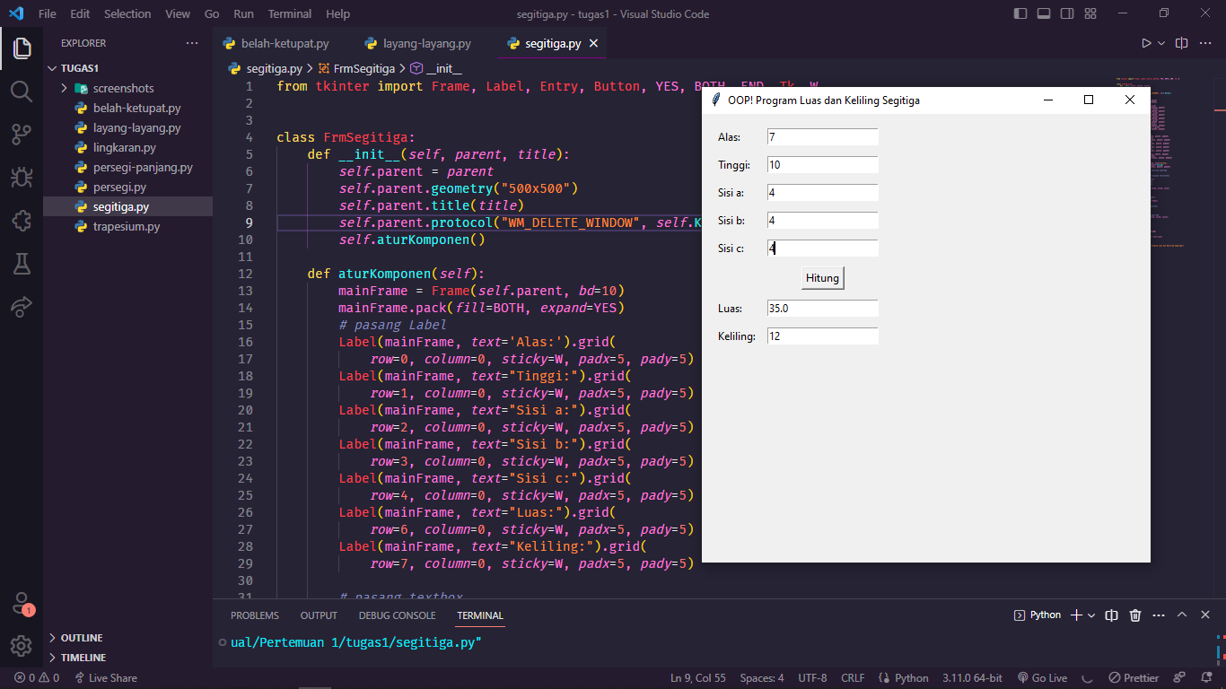

1. **Persegi / Bujur Sangkar**

Source Code ;

from tkinter import Frame, Label, Entry, Button, YES, BOTH, END, Tk, W

class FrmPersegi:

def __init__(self, parent, title):

self.parent = parent

self.parent.geometry("500x500")

self.parent.title(title)

self.parent.protocol("WM_DELETE_WINDOW", self.Keluar)

self.aturKomponen()

def aturKomponen(self):

mainFrame = Frame(self.parent, bd=10)

mainFrame.pack(fill=BOTH, expand=YES)

# pasang Label

Label(mainFrame, text='Sisi :').grid(row=0, column=0,

sticky=W, padx=5, pady=5)

Label(mainFrame, text="Luas:").grid(row=2, column=0,

sticky=W, padx=5, pady=5)

Label(mainFrame, text="Keliling:").grid(row=3, column=0,

sticky=W, padx=5, pady=5)

# pasang textbox

self.txtSisi = Entry(mainFrame)

self.txtSisi.grid(row=0, column=1, padx=5, pady=5)

self.txtLuas = Entry(mainFrame)

self.txtLuas.grid(row=2, column=1, padx=5, pady=5)

self.txtKeliling = Entry(mainFrame)

self.txtKeliling.grid(row=3, column=1, padx=5, pady=5)

# Pasang Button

self.btnHitung = Button(mainFrame, text='Hitung',

command=self.Hitung)

self.btnHitung.grid(row=1, column=1, padx=5, pady=5)

# fungsi untuk menghitung luas dan keliling persegi

def Hitung(self, event=None):

# perhitungan dengan metode Pemrograman Terstruktur

sisi = int(self.txtSisi.get())

perseg = persegi(sisi)

luas = perseg.luas()

kel = perseg.keliling()

self.txtLuas.delete(0, END)

self.txtLuas.insert(END, str(luas))

self.txtKeliling.delete(0, END)

self.txtKeliling.insert(END, str(kel))

def Keluar(self, event=None):

# memberikan perintah menutup aplikasi

self.parent.destroy()

class persegi():

def __init__(self, sisi):

self.sisi = sisi

def luas(self):

return self.sisi * self.sisi

def keliling(self):

return (4 * self.sisi)

if __name__ == '__main__':

root = Tk()

aplikasi = FrmPersegi(root, "OOP! Program Luas dan Keliling Persegi")

root.mainloop()

Hasil Program Persegi / Bujur Sangkar



1. **Lingkaran**

Source Code :

from tkinter import Frame, Label, Entry, Button, YES, BOTH, END, Tk, W

class FrmLingkaran:

def __init__(self, parent, title):

self.parent = parent

self.parent.geometry("500x500")

self.parent.title(title)

self.parent.protocol("WM_DELETE_WINDOW", self.Keluar)

self.aturKomponen()

def aturKomponen(self):

mainFrame = Frame(self.parent, bd=10)

mainFrame.pack(fill=BOTH, expand=YES)

# pasang Label

Label(mainFrame, text='Jari Jari :').grid(

row=0, column=0, sticky=W, padx=5, pady=5)

Label(mainFrame, text="Luas:").grid(

row=2, column=0, sticky=W, padx=5, pady=5)

Label(mainFrame, text="Keliling:").grid(

row=3, column=0, sticky=W, padx=5, pady=5)

# pasang textbox

self.txtjari = Entry(mainFrame)

self.txtjari.grid(row=0, column=1, padx=5, pady=5)

self.txtLuas = Entry(mainFrame)

self.txtLuas.grid(row=2, column=1, padx=5, pady=5)

self.txtKeliling = Entry(mainFrame)

self.txtKeliling.grid(row=3, column=1, padx=5, pady=5)

# Pasang Button

self.btnHitung = Button(mainFrame, text='Hitung',

command=self.Hitung)

self.btnHitung.grid(row=1, column=1, padx=5, pady=5)

# fungsi untuk menghitung luas dan keliling lingkaran

def Hitung(self, event=None):

# perhitungan dengan metode Pemrograman Terstruktur

jari = float(self.txtjari.get())

bunder = lingkaran(jari)

luas = bunder.luas()

kel = bunder.keliling()

self.txtLuas.delete(0, END)

self.txtLuas.insert(END, str(luas))

self.txtKeliling.delete(0, END)

self.txtKeliling.insert(END, str(kel))

def Keluar(self, event=None):

# memberikan perintah menutup aplikasi

self.parent.destroy()

class lingkaran():

# perhitungan dengan metode Pemrograman OOP

def __init__(self, jari):

self.jari = jari

def luas(self):

return 3.14 * (self.jari * self.jari)

def keliling(self):

return 2 * 3.14 * self.jari

if __name__ == '__main__':

root = Tk()

aplikasi = FrmLingkaran(root, "OOP! Program Luas dan Keliling Lingkaran")

root.mainloop()

Hasil Program Lingkaran ;

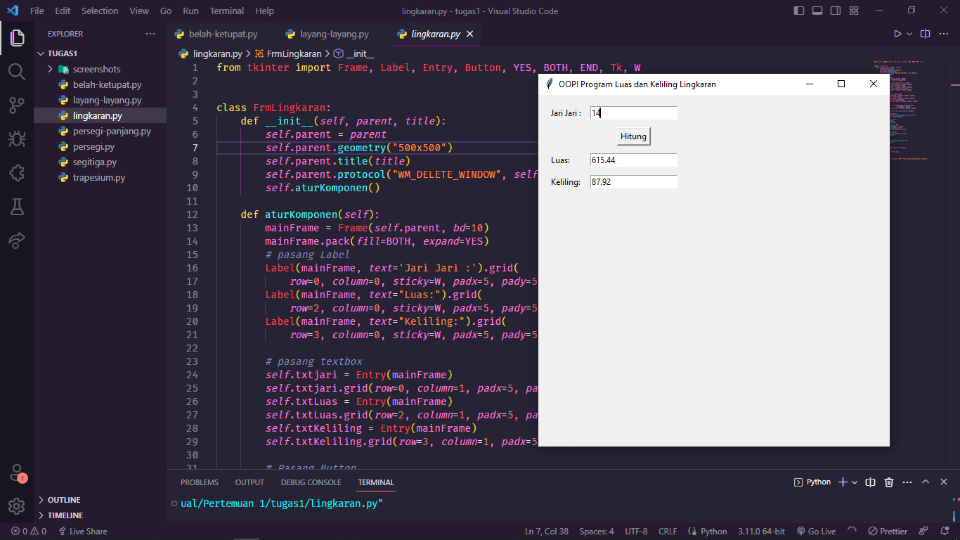

1. **Trapesium**

Source Code :

from tkinter import Frame, Label, Entry, Button, YES, BOTH, END, Tk, W

class FrmTrapesium:

def __init__(self, parent, title):

self.parent = parent

self.parent.geometry("500x500")

self.parent.title(title)

self.parent.protocol("WM_DELETE_WINDOW", self.Keluar)

self.aturKomponen()

def aturKomponen(self):

mainFrame = Frame(self.parent, bd=10)

mainFrame.pack(fill=BOTH, expand=YES)

# pasang Label

Label(mainFrame, text='Alas a :').grid(

row=0, column=0, sticky=W, padx=5, pady=5)

Label(mainFrame, text='Alas b :').grid(

row=1, column=0, sticky=W, padx=5, pady=5)

Label(mainFrame, text='Tinggi :').grid(

row=2, column=0, sticky=W, padx=5, pady=5)

Label(mainFrame, text='Sisi a:').grid(

row=3, column=0, sticky=W, padx=5, pady=5)

Label(mainFrame, text='Sisi b:').grid(

row=4, column=0, sticky=W, padx=5, pady=5)

Label(mainFrame, text='Sisi c:').grid(

row=5, column=0, sticky=W, padx=5, pady=5)

Label(mainFrame, text='Sisi d:').grid(

row=6, column=0, sticky=W, padx=5, pady=5)

Label(mainFrame, text="Luas :").grid(

row=8, column=0, sticky=W, padx=5, pady=5)

Label(mainFrame, text="Keliling :").grid(

row=9, column=0, sticky=W, padx=5, pady=5)

# pasang textbox

self.txtalasa = Entry(mainFrame)

self.txtalasa.grid(row=0, column=1, padx=5, pady=5)

self.txtalasb = Entry(mainFrame)

self.txtalasb.grid(row=1, column=1, padx=5, pady=5)

self.txttinggi = Entry(mainFrame)

self.txttinggi.grid(row=2, column=1, padx=5, pady=5)

self.txtsisia = Entry(mainFrame)

self.txtsisia.grid(row=3, column=1, padx=5, pady=5)

self.txtsisib = Entry(mainFrame)

self.txtsisib.grid(row=4, column=1, padx=5, pady=5)

self.txtsisic = Entry(mainFrame)

self.txtsisic.grid(row=5, column=1, padx=5, pady=5)

self.txtsisid = Entry(mainFrame)

self.txtsisid.grid(row=6, column=1, padx=5, pady=5)

self.txtLuas = Entry(mainFrame)

self.txtLuas.grid(row=8, column=1, padx=5, pady=5)

self.txtKeliling = Entry(mainFrame)

self.txtKeliling.grid(row=9, column=1, padx=5, pady=5)

# Pasang Button

self.btnHitung = Button(mainFrame, text='Hitung',

command=self.Hitung)

self.btnHitung.grid(row=7, column=1, padx=5, pady=5)

# fungsi untuk menghitung luas dan keliling trapesium

def Hitung(self, event=None):

# perhitungan dengan metode Pemrograman Terstruktur

alasa = int(self.txtalasa.get())

alasb = int(self.txtalasb.get())

tinggi = int(self.txttinggi.get())

sisia = int(self.txtsisia.get())

sisib = int(self.txtsisib.get())

sisic = int(self.txtsisic.get())

sisid = int(self.txtsisid.get())

trapes = trapesium(alasa, alasb, tinggi, sisia, sisib, sisic, sisid)

luas = trapes.luas()

kel = trapes.keliling()

self.txtLuas.delete(0, END)

self.txtLuas.insert(END, str(luas))

self.txtKeliling.delete(0, END)

self.txtKeliling.insert(END, str(kel))

def Keluar(self, event=None):

# memberikan perintah menutup aplikasi

self.parent.destroy()

class trapesium():

# perhitungan dengan metode Pemrograman OOP

def __init__(self, alasa, alasb, tinggi, sisia, sisib, sisic, sisid):

self.alasa = alasa

self.alasb = alasb

self.tinggi = tinggi

self.sisia = sisia

self.sisib = sisib

self.sisic = sisic

self.sisid = sisid

def luas(self):

return 1/2 * (self.alasa + self.alasb) * self.tinggi

def keliling(self):

return self.sisia + self.sisib + self.sisic + self.sisid

if __name__ == '__main__':

root = Tk()

aplikasi = FrmTrapesium(root, "OOP! Program Luas dan Keliling Trapesium")

root.mainloop()

Hasil Program Trapesium :

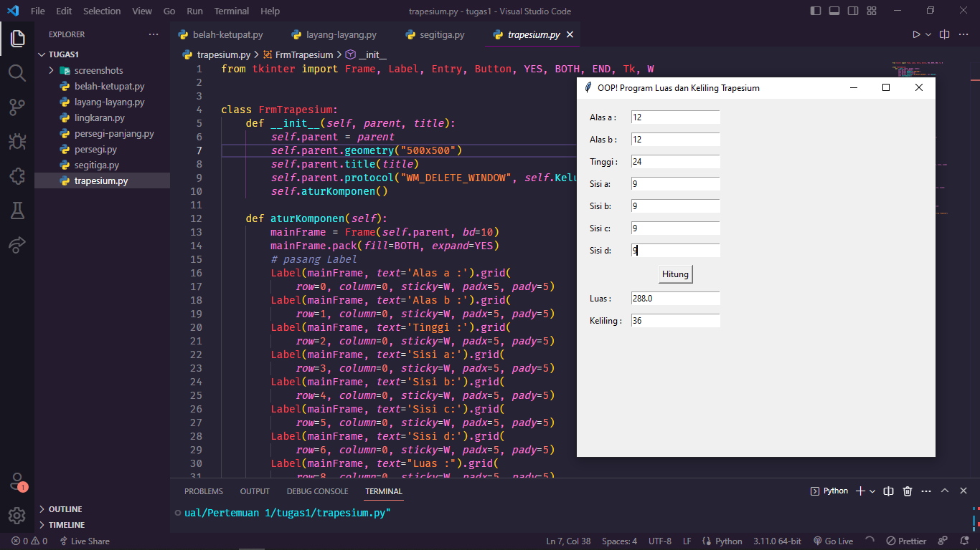

1. **Layang-layang**

Source Code ;

from tkinter import Frame, Label, Entry, Button, YES, BOTH, END, Tk, W

class FrmLayang:

def __init__(self, parent, title):

self.parent = parent

self.parent.geometry("500x500")

self.parent.title(title)

self.parent.protocol("WM_DELETE_WINDOW", self.Keluar)

self.aturKomponen()

def aturKomponen(self):

mainFrame = Frame(self.parent, bd=10)

mainFrame.pack(fill=BOTH, expand=YES)

# pasang Label

Label(mainFrame, text='Diagonal 1 :').grid(

row=0, column=0, sticky=W, padx=5, pady=5)

Label(mainFrame, text='Diagonal 2 :').grid(

row=1, column=0, sticky=W, padx=5, pady=5)

Label(mainFrame, text='Sisi Pendek Layang :').grid(

row=2, column=0, sticky=W, padx=5, pady=5)

Label(mainFrame, text='Sisi Panjang Layang :').grid(

row=3, column=0, sticky=W, padx=5, pady=5)

Label(mainFrame, text="Luas:").grid(

row=5, column=0, sticky=W, padx=5, pady=5)

Label(mainFrame, text="Keliling:").grid(

row=6, column=0, sticky=W, padx=5, pady=5)

# pasang textbox

self.txtdiagonal1 = Entry(mainFrame)

self.txtdiagonal1.grid(row=0, column=1, padx=5, pady=5)

self.txtdiagonal2 = Entry(mainFrame)

self.txtdiagonal2.grid(row=1, column=1, padx=5, pady=5)

self.txtsisiPendek = Entry(mainFrame)

self.txtsisiPendek.grid(row=2, column=1, padx=5, pady=5)

self.txtsisiPanjang = Entry(mainFrame)

self.txtsisiPanjang.grid(row=3, column=1, padx=5, pady=5)

self.txtLuas = Entry(mainFrame)

self.txtLuas.grid(row=5, column=1, padx=5, pady=5)

self.txtKeliling = Entry(mainFrame)

self.txtKeliling.grid(row=6, column=1, padx=5, pady=5)

# Pasang Button

self.btnHitung = Button(mainFrame, text='Hitung',

command=self.Hitung)

self.btnHitung.grid(row=4, column=1, padx=5, pady=5)

# fungsi untuk menghitung luas dan keliling layang-layang

def Hitung(self, event=None):

# perhitungan dengan metode Pemrograman Terstruktur

d1 = int(self.txtdiagonal1.get())

d2 = int(self.txtdiagonal2.get())

sisiPendek = int(self.txtsisiPendek.get())

sisiPanjang = int(self.txtsisiPanjang.get())

lyg = layang(d1, d2, sisiPendek, sisiPanjang)

luas = lyg.luas()

kel = lyg.keliling()

self.txtLuas.delete(0, END)

self.txtLuas.insert(END, str(luas))

self.txtKeliling.delete(0, END)

self.txtKeliling.insert(END, str(kel))

def Keluar(self, event=None):

# memberikan perintah menutup aplikasi

self.parent.destroy()

class layang():

# perhitungan dengan metode Pemrograman OOP

def __init__(self, d1, d2, sisiPendek, sisiPanjang):

self.d1 = d1

self.d2 = d2

self.sisiPendek = sisiPendek

self.sisiPanjang = sisiPanjang

def luas(self):

return 1/2 * (self.d1 * self.d2)

def keliling(self):

return 2 * (self.sisiPendek + self.sisiPanjang)

if __name__ == '__main__':

root = Tk()

aplikasi = FrmLayang(root, "OOP! Program Luas dan Keliling Layang Layang")

root.mainloop()

Hasil Program Layang-layang :

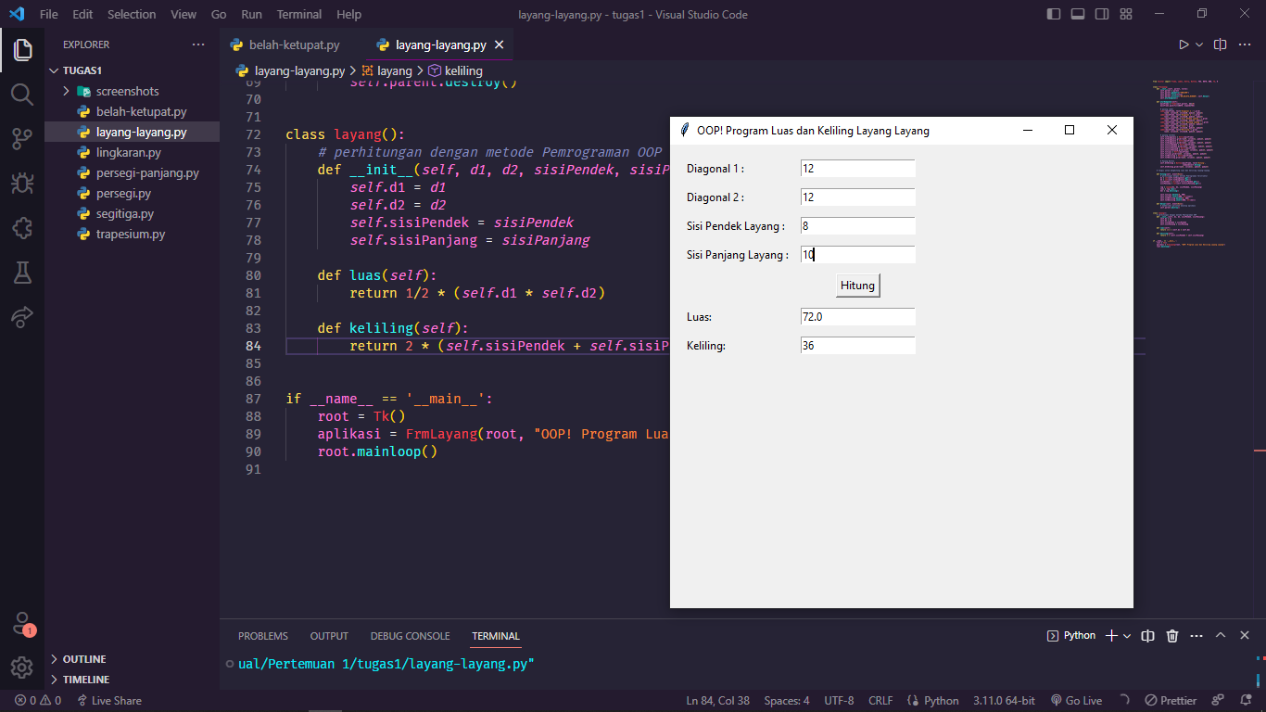

1. **Belah Ketupat**

Source Code :

from tkinter import Frame, Label, Entry, Button, YES, BOTH, END, Tk, W

class FrmBelahKetupat:

def __init__(self, parent, title):

self.parent = parent

self.parent.geometry("500x500")

self.parent.title(title)

self.parent.protocol("WM_DELETE_WINDOW", self.Keluar)

self.aturKomponen()

def aturKomponen(self):

mainFrame = Frame(self.parent, bd=10)

mainFrame.pack(fill=BOTH, expand=YES)

# pasang Label

Label(mainFrame, text='Diagonal 1 :').grid(

row=0, column=0, sticky=W, padx=5, pady=5)

Label(mainFrame, text='Diagonal 2 :').grid(

row=1, column=0, sticky=W, padx=5, pady=5)

Label(mainFrame, text='Sisi :').grid(

row=2, column=0, sticky=W, padx=5, pady=5)

Label(mainFrame, text="Luas :").grid(

row=4, column=0, sticky=W, padx=5, pady=5)

Label(mainFrame, text="Keliling :").grid(

row=5, column=0, sticky=W, padx=5, pady=5)

# pasang textbox

self.txtdiagonal1 = Entry(mainFrame)

self.txtdiagonal1.grid(row=0, column=1, padx=5, pady=5)

self.txtdiagonal2 = Entry(mainFrame)

self.txtdiagonal2.grid(row=1, column=1, padx=5, pady=5)

self.txtsisi = Entry(mainFrame)

self.txtsisi.grid(row=2, column=1, padx=5, pady=5)

self.txtLuas = Entry(mainFrame)

self.txtLuas.grid(row=4, column=1, padx=5, pady=5)

self.txtKeliling = Entry(mainFrame)

self.txtKeliling.grid(row=5, column=1, padx=5, pady=5)

# Pasang Button

self.btnHitung = Button(mainFrame, text='Hitung',

command=self.Hitung)

self.btnHitung.grid(row=3, column=1, padx=5, pady=5)

# fungsi untuk menghitung luas dan keliling belah ketupat

def Hitung(self, event=None):

# perhitungan dengan metode Pemrograman Terstruktur

d1 = int(self.txtdiagonal1.get())

d2 = int(self.txtdiagonal2.get())

sisi = int(self.txtsisi.get())

belah = belahketupat(d1, d2, sisi)

luas = belah.luas()

kel = belah.keliling()

self.txtLuas.delete(0, END)

self.txtLuas.insert(END, str(luas))

self.txtKeliling.delete(0, END)

self.txtKeliling.insert(END, str(kel))

def Keluar(self, event=None):

# memberikan perintah menutup aplikasi

self.parent.destroy()

class belahketupat():

# perhitungan dengan metode Pemrograman OOP

def __init__(self, d1, d2, sisi):

self.d1 = d1

self.d2 = d2

self.sisi = sisi

def luas(self):

return 1/2 * (self.d1 * self.d2)

def keliling(self):

return 4 * self.sisi

if __name__ == '__main__':

root = Tk()

aplikasi = FrmBelahKetupat(root, "OOP! Program Luas dan Keliling Belah Ketupat")

root.mainloop()

Hasil Program Belah Ketupat ;

